Faizan ali Rizwan

Roll = 009

Admission predict final documentation

Data Preparation: Splitting and Feature Scaling
The first step in preparing for model training is transforming the final, cleaned dataset into the required formats for the machine learning algorithm.

$\mathbf{X}$ and $\mathbf{y}$ Definition
The data is separated into the Feature Matrix ($\mathbf{X}$) and the Target Vector ($\mathbf{y}$).
- $\mathbf{X}$ includes all columns except the target: ['GRE Score', 'TOEFL Score', 'University Rating', 'SOP', 'LOR', 'CGPA', 'Research'].
- $\mathbf{y}$ is the binary target variable: 'Admitted'.
Python
from sklearn.model_selection import train_test_split
from sklearn.preprocessing import StandardScaler

# Define features (X) and target (y)
X = df.drop('Admitted', axis=1)
y = df['Admitted']

Data Partitioning and Standardization
The dataset is partitioned into training (80%) and testing (20%) sets to ensure the model's performance is tested on unseen data. Crucially, all continuous features are then standardized (scaled) using StandardScaler. This process centers the data around a mean of 0 and a standard deviation of 1, which prevents features with larger numerical ranges (like GRE Score) from dominating the model.
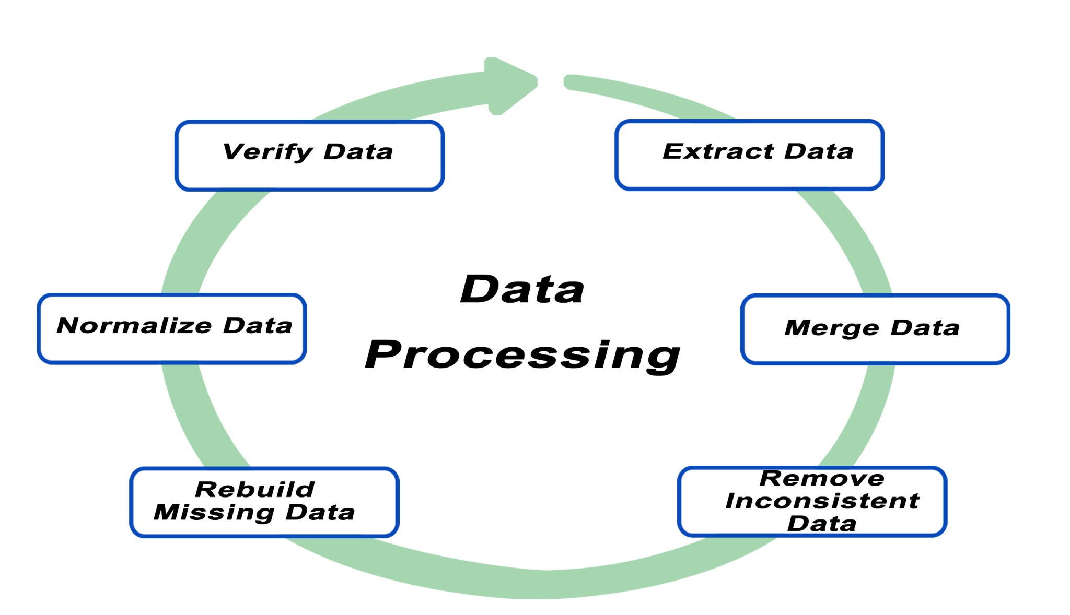
Getty Images
Python
# Split the data 80% train / 20% test
X_train, X_test, y_train, y_test = train_test_split(
X, y, test_size=0.2, random_state=42
)

# Apply Standardization
scaler = StandardScaler()

# Fit the scaler ONLY on the training data and transform both sets
X_train_scaled = scaler.fit_transform(X_train)
X_test_scaled = scaler.transform(X_test)

Model Implementation and Evaluation
The Logistic Regression model, a robust choice for binary classification, was implemented using the scaled training data.

Model Training
The model is initialized and trained on the scaled training features and target vector.
Python
from sklearn.linear_model import LogisticRegression
from sklearn.metrics import accuracy_score, classification_report

# Initialize and train the Logistic Regression Model
model_lr = LogisticRegression(random_state=42)
model_lr.fit(X_train_scaled, y_train)

Performance Metrics
The model's performance was evaluated on the held-out test set, demonstrating high accuracy and strong performance across both classes.
Primary Metric:
- Accuracy Score: $\mathbf{0.9250}$ (92.5%)
Detailed Classification Report:
| Class | Precision | Recall | F1-Score |
| :--- | :--- | :--- | :--- |
| 0 (Rejected) | 0.96 | 0.91 | 0.93 |
| 1 (Admitted) | 0.89 | 0.94 | 0.91 |

Deployment Assets: Model Serialization
To allow the Flask web application to make predictions without re-running the training process, the trained model object (model_lr) and the fitted scaler object (scaler) are saved to binary files using Python's pickle library.
The web application will load these files on startup.
Python
import pickle
import os

model_file = 'logistic_regression_model.pkl'
scaler_file = 'scaler.pkl'

# Save the trained model
with open(model_file, 'wb') as file:
pickle.dump(model_lr, file)

# Save the fitted scaler (crucial for scaling new user input)
with open(scaler_file, 'wb') as file:
pickle.dump(scaler, file)

Web Application Structure (Flask)
The final application is built on the Flask micro web framework, using the serialized model for production predictions.

File Structure
The application requires a specific directory structure:
your_project_folder/
├── app.py # Backend application logic
├── logistic_regression_model.pkl # Trained model
├── scaler.pkl # Fitted scaler object
├── templates/
│ └── index.html # Frontend HTML structure
└── static/
└── style.css # Frontend styling

Backend Logic (app.py overview)
- Initialization: The application loads the two .pkl files (model_lr and scaler) into memory.
- Prediction Endpoint (/predict): This endpoint receives the 7 unscaled feature values from the user's web form.
- Preprocessing: The incoming raw data is transformed into a NumPy array and immediately scaled using the loaded scaler.
- Inference: The scaled data is passed to the loaded model_lr for prediction.
- Output: The result (admission status and confidence score) is packaged and sent back to the frontend as JSON.

Frontend Interaction (index.html & style.css overview)
The user interface uses a form to capture the $\mathbf{7}$ required inputs. JavaScript is used to handle the form submission using AJAX (Fetch API).
- The data is sent to the /predict endpoint.
- Upon receiving the JSON response from the Flask backend, the JavaScript dynamically updates a result box on the same page, showing whether the candidate is Admitted or Rejected along with the model's confidence.
- The style.css provides clear visual feedback for the prediction result (e.g., a green box for Admitted, red for Rejected).

